Proposal on

**Smart Irrigation System (IOT based)**



Submitted to

**Department of Computer Science and Engineering**

**Nepal Engineering College**

in Partial Fulfillment of the

Requirements for the Degree of B.E. in Computer

Submitted By

Aashika Pandey (022-391)

Rubi Adhikari (022-368)

Shristi Dhakal (022-376)

Date: 06/12/2024

**Abstract**

Efficient water management is essential for sustainable agriculture, especially amidst global challenges such as water scarcity, population growth, and the increasing demand for food. This study introduces an IoT-based smart irrigation system that automates water delivery based on real-time soil moisture data. The system integrates a soil moisture sensor, Node MCU microcontroller, and relay module to activate water pumps as needed, while wireless communication enables remote monitoring and control via mobile or web applications. The research highlights the limitations of traditional irrigation methods, such as water wastage and inconsistent watering, and demonstrates how IoT-enabled solutions can optimize water usage. The system's design combines advanced sensors, wireless networks, and cloud-based platforms to ensure precise irrigation, promoting healthier crops and reducing resource wastage.

**Keywords:** Internet of Things, Irrigation system, soil moisture sensor

**Table of Contents**

Chapter 1: Introduction 1

1.1 Background 1

1.2 Problem statement 1

1.3 Aims and Objectives 2

1.3.1 Aims 2

1.3.2 Objectives 2

1.4 Motivation 2

Chapter 2: Literature Review 3

Chapter 3: System Design 5

Chapter 4: Expected Output 8

Chapter 5: Conclusion 9

References 10

**List of Figures**

Figure‑1: Flowchart of smart irrigation system…………………………………………...5

Figure‑2: Use Case Diagram of Smart irrigation system 7

Figure-3: Board Diagram of smart irrigation system...........................................................7

**Abbreviations**

1. IoT: Internet of Things
2. SAS: Smart Agriculture System
3. MCU: Micro Controller Unit
4. ESP: Event Stream Processing

# Chapter 1: Introduction

## Background

In modern agriculture, efficient water management is crucial for enhancing crop yield and ensuring sustainable farming practices. Our IoT irrigation system addresses this need by automating the irrigation process based on real-time soil moisture levels. The system utilizes a soil moisture sensor to continuously monitor the moisture content of the soil. When the sensor detects that the soil is dry, it triggers a water pump to irrigate the crops, ensuring they receive the necessary hydration for optimal growth. This automated approach not only conserves water but also promotes healthier crop development by providing precise irrigation when needed. At the core of our system is the NODEMCU, an open-source IoT platform that enables easy connectivity and control over the irrigation process. The ESP module facilitates wireless communication, allowing farmers to monitor and manage their irrigation system remotely. Additionally, a relay module is used to control the water pump, ensuring that it operates only when required. By integrating these components, our IoT irrigation system provides an innovative solution for farmers, enhancing crop growth while promoting efficient water usage. This technology represents a significant advancement in agricultural practices, contributing to increased productivity and sustainability in farming.

## 1.2 Problem statement

Traditional irrigation systems are often waste water and are inefficient, leading to overwatering, underwatering, inconsistent watering and environmental impact. Efficient water management is a challenge in modern agriculture, with traditional irrigation methods often leading to overwatering or under-watering, resulting in water wastage, reduced crop yield and increased costs. Farmers face difficulties in monitoring soil levels and managing irrigation schedules effectively. To address these challenges, a smart irrigation **s**ystem using IoTcan be developed to optimize water usage and automate irrigation process. This system leverages sensors such as soil moisture and make data-drive decisions. Using the IoT-enabled devices, farmers can remotely monitor and control irrigation system through mobile or web applications, reducing labor dependency and operational costs.

## 1.3 Aims and Objectives

### 1.3.1 Aims

The main aim of this project is to develop a user-friendly NodeMCU based Smart Agricultural Monitoring and interface, cost and work efficient technology that will benefit everyone involved in agriculture.

### 1.3.2 Objectives

* To learn about different devices that we are using to build this project like node, soil moisture, water motors.
* To develop a system that can water the soil by monitoring the moisture of soil by using sensors.
* To implement the knowledge of hardware, software and programming language on IOT projects.
* To implement automated irrigation systems that adjust water supply according to crop needs, reducing water wastage.
* To automate the irrigation system.

## 1.4 Motivation

The increasing population growth and need for food require more effective innovations within agriculture practice. IoT technology in agriculture and irrigation systems, in particular may radically change how we consume the water resources through detailed monitoring, automated responses, and remote control of the irrigation systems. Productivity may increase while reducing cost and saving water resources through IoT systems.

# Chapter 2: Literature Review

The development of automated irrigation systems that monitor soil moisture and supply water efficiently is increasingly vital in modern agriculture, particularly in the context of water scarcity and the need for sustainable farming practices. These systems leverage advanced technologies, including microcontrollers, sensors, and wireless communication, to optimize water usage and enhance crop yield.

Automated irrigation systems utilize soil moisture sensors to continuously monitor the moisture levels in the soil. These sensors can be based on various technologies, including capacitance and resistive methods. Capacitance-based sensors, for instance, have been shown to outperform resistive sensors in terms of durability and accuracy, making them suitable for long-term use in smart irrigation systems [10] [9]. The integration of these sensors with microcontrollers, such as Arduino or Raspberry Pi, allows for real-time data processing and decision-making regarding irrigation needs [1] [11]. For example, when soil moisture levels drop below a predefined threshold, the system can automatically activate a water pump to irrigate the crops, ensuring that plants receive adequate water without human intervention [2] [3].

Moreover, the deployment of wireless sensor networks (WSNs) enhances the capability of these irrigation systems by enabling the collection of data from multiple sensors distributed across a field. This approach allows for a more comprehensive understanding of soil moisture variability, which is crucial for implementing regulated deficit irrigation (RDI) strategies [5] [7]. By adjusting irrigation schedules based on real-time data, farmers can significantly reduce water usage while maintaining optimal soil moisture levels for crop [12]. The use of solar-powered sensors further contributes to the sustainability of these systems, reducing reliance on external power sources and minimizing operational costs [8], [7].

In addition to traditional soil moisture sensors, innovative methods such as smartphone-based sensors and satellite data analytics are emerging as valuable tools for monitoring soil conditions. Smartphone applications can process images to estimate soil moisture levels, providing an accessible and cost-effective solution for farmers [6]. Similarly, machine learning techniques applied to satellite data can predict soil moisture content, offering insights that complement ground-based measurements [4]. These advancements not only enhance the precision of irrigation management but also support broader agricultural practices aimed at increasing efficiency and sustainability.

In conclusion, automated irrigation systems that incorporate soil moisture monitoring technologies represent a transformative approach to modern agriculture. By utilizing a combination of advanced sensors, microcontrollers, and data analytics, these systems can optimize water usage, reduce waste, and improve crop yields, thereby addressing the challenges posed by water scarcity and environmental sustainability.

# Chapter 3: System Design

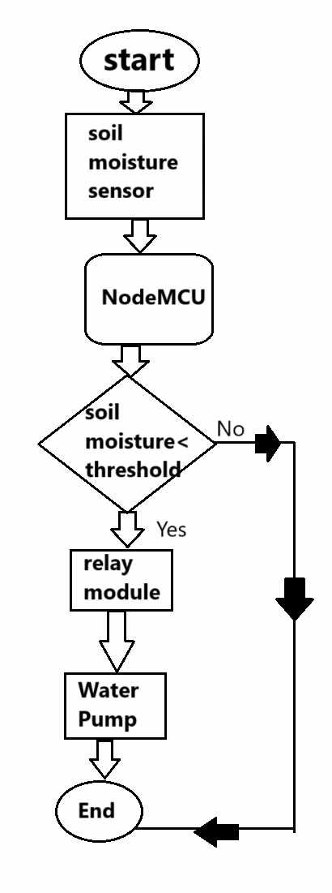

Figure 1: Flowchart of smart irrigation system

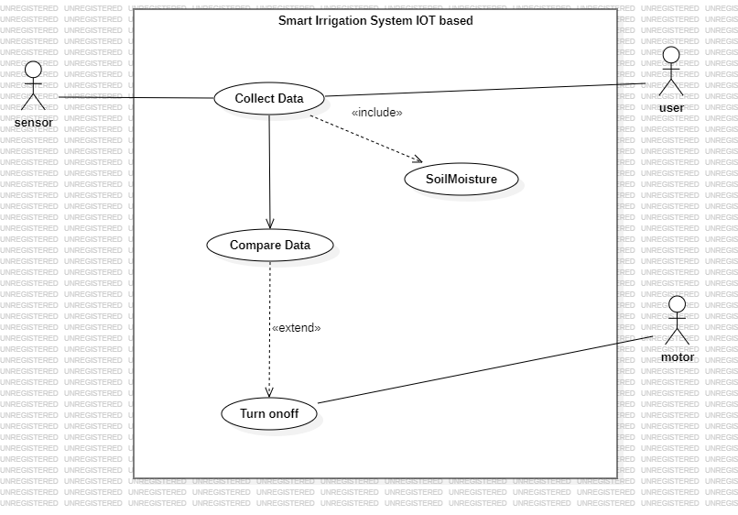*Figure 2: Use Case Diagram of Smart irrigation system*

A smart irrigation system using IoT is designed to optimize water usage and enhance crop management by automating irrigation based on real-time environmental data. It integrates a network of sensors, such as soil moisture, temperature, humidity, and rainfall detectors, to monitor conditions and send data to a microcontroller like ESP32 or Arduino. The system analyzes this data against predefined thresholds to decide when and how much water is needed. Actuators such as water pumps and valves are then triggered to deliver precise amounts of water through sprinklers or drip systems to specific zones, reducing waste and improving efficiency.

The system is connected to the internet via IoT communication modules, such as wi-fi, or GMS, enabling remote monitoring and control through a cloud-based platform. Users can access a mobile app or web dashboard to view real-time data, adjust settings, or manually override operations. Additionally, the cloud stores historical data for advanced analytics, allowing predictive insights for better crop planning. Solar panels with battery backup can power the system in off-grid areas, making it sustainable and suitable for remote farming applications.

This smart system not only automates irrigation but also provides alerts for anomalies, such as sensor failures or low water levels. By optimizing water use and offering remote access, it reduces labor, enhances productivity, and supports sustainable agriculture. However, challenges like initial costs, maintenance, and connectivity in rural areas must be addressed to ensure its effectiveness and scalability.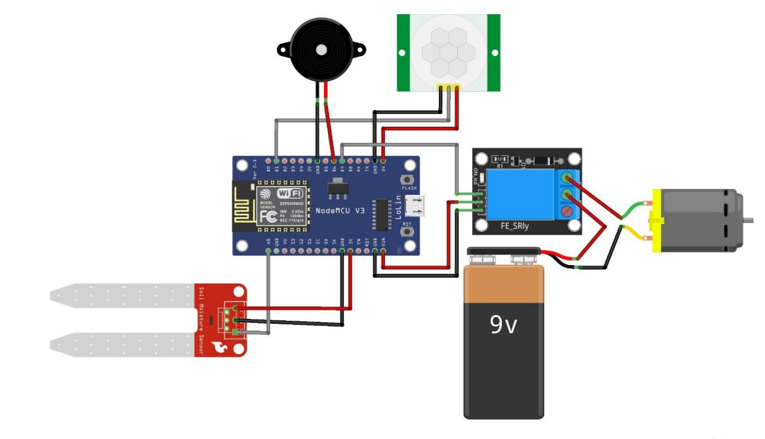

Figure 3: Board Diagram of Smart irrigation system

# Chapter 4: Expected Output

1**.** A smart irrigation system automates and optimizes watering by using sensors to monitor soil moisture and crop needs.

2. Based on real-time data, ensures efficient water usage and preventing over- or under-watering.

3. Provides remote control through mobile apps or web interfaces, allowing users to make adjustments as needed.

4. Enhances resource efficiency, saves costs, and promotes sustainable agricultural practices.

# Chapter 5: Conclusion

# A smart irrigation system using soil moisture sensors ensures water is applied only when needed by monitoring moisture levels in the soil. The system automatically adjusts watering schedules based on the data from these sensors, preventing overwatering and reducing water waste. This leads to healthier plants, better crop yields, and lower water costs. By delivering water precisely when the soil reaches a critical dryness threshold, it promotes efficient resource use and sustainability. The system also helps save time and effort by automating irrigation and reducing the need for manual monitoring and watering.

# References

1. (2023). Automatic irrigation system using arduino uno. International Journal of Progressive Research in Engineering Management and Science. https://doi.org/10.58257/ijprems31943
2. (2024). Automatic irrigation system with remote monitoring facility. International Research Journal of Modernization in Engineering Technology and Science. https://doi.org/10.56726/irjmets48079
3. Asha, Y. (2019). Smart irrigation sytem using internet of things. International Journal for Research in Applied Science and Engineering Technology, 7(5), 3346-3351. https://doi.org/10.22214/ijraset.2019.5550
4. Efremova, N. (2019). Prediction of soil moisture content based on satellite data and sequence-to-sequence networks. https://doi.org/10.48550/arxiv.1907.03697
5. García, L., Parra, L., Jiménez, J., Parra, M., Lloret, J., Mauri, P., … & Lorenz, P. (2021). Deployment strategies of soil monitoring wsn for precision agriculture irrigation scheduling in rural areas. Sensors, 21(5), 1693. https://doi.org/10.3390/s21051693
6. Jaguey, J., Villa-Medina, J., Lopez-Guzman, A., & Porta-Gándara, M. (2015). Smartphone irrigation sensor. Ieee Sensors Journal, 15(9), 5122-5127. https://doi.org/10.1109/jsen.2015.2435516
7. Lin, L., Gu, W., Li, X., & Shen, G. (2017). Soil moisture monitoring system based on wireless sensor network. https://doi.org/10.2991/isaeece-17.2017.73
8. Okasha, A., Ibrahim, H., Elmetwalli, A., Khedher, K., Yaseen‬‬‬‬‬‬‬‬‬‬‬‬‬‬‬‬, Z., & Elsayed, S. (2021). Designing low-cost capacitive-based soil moisture sensor and smart monitoring unit operated by solar cells for greenhouse irrigation management. Sensors, 21(16), 5387. https://doi.org/10.3390/s21165387
9. Placidi, P., Gasperini, L., Grassi, A., Cecconi, M., & Scorzoni, A. (2020). Characterization of low-cost capacitive soil moisture sensors for iot networks. Sensors, 20(12), 3585. https://doi.org/10.3390/s20123585
10. Pramanik, M., Khanna, M., Singh, M., Singh, D., Sudhishri, S., Bhatia, A., … & Ranjan, R. (2023). Evaluation of capacitance-based soil moisture sensors in iot based automatic basin irrigation system. https://doi.org/10.21203/rs.3.rs-3043138/v1
11. Sunehra, D. (2019). Web based smart irrigation system using raspberry pi. International Journal of Advanced Research in Engineering & Technology, 10(2). https://doi.org/10.34218/ijaret.10.2.2019.006
12. Surve, V. (2024). Sensor based irrigation management in crop production: a review. Annual Research & Review in Biology, 39(4), 1-4. https://doi.org/10.9734/arrb/2024/v39i42068